**Design Thinking Project Workbook**

**Don't find customers for your product but find products for your customers**

**1. Team**

**Team Name:**

**Team Logo (if any):**

**Team Members:**

1. [Hema Mayukha Vasireddy, 2320040020, 76720 41744 ]
2. [Anishka Sree Rapolu, 2320040041, 89194 35513]
3. [Sowmya Sree I, 2320040031, 90003 67595]

**2. Problem/Opportunity Domain**

**Domain of Interest:** bioinformatics and computational biology

**Description of the Domain:** protein structure prediction, which is a key area of research in molecular biology, biochemistry, and bioinformatics, involving the use of machine learning and computational tools to model protein structures from amino acid sequences.

**Why did you choose this domain?:** We chose this project because protein structure prediction plays a crucial role in understanding the biological functions of proteins, aiding in the discovery of new drugs, treatments for diseases, and innovations in biotechnology. Experimentally determining protein structures is often time-consuming and expensive, making it impractical to analyse large numbers of proteins. A computational approach allows for faster and cost-effective predictions, potentially transforming areas like drug design, genomics, and personalized medicine by predicting how proteins behave, interact, and can be targeted for therapeutic purposes.

**3. Problem/Opportunity Statement**

**Problem Statement:** 3D Structure Prediction from Protein Sequences Using Computational Methods

**Problem Description:** Proteins, essential molecular machines within biological systems, derive their function from their three-dimensional (3D) structures. Experimentally determining these structures is often labour-intensive and costly. This project aims to develop a computational approach to predict the 3D structure of a protein directly from its amino acid sequence, utilizing a combination of bioinformatics tools and machine learning algorithms.

**Context (When does the problem occur):** The problem arises when researchers need to determine the three-dimensional structure of a protein but lack the resources or time for experimental methods like X-ray crystallography, cryo-electron microscopy, or NMR spectroscopy. These methods can take months to years and require expensive equipment and specialized expertise. The challenge occurs particularly when analyzing large datasets of proteins (such as in genomics projects) or when exploring proteins that are difficult to crystallize or study experimentally. This issue becomes even more critical in urgent situations, such as drug discovery for new diseases or understanding proteins related to pandemics.

**Alternatives (What does the customer do to fix the problem):** Customers, such as researchers or pharmaceutical companies, often rely on bioinformatics databases with pre-determined structures, or they may use homology modeling to predict the structure based on known structures of similar proteins. Additionally, AlphaFold, a deep learning-based approach, is increasingly being used for high-accuracy predictions. However, for less common proteins or proteins with low sequence similarity to known structures, these methods can still be inaccurate or insufficient. Researchers may also collaborate with structural biology labs for experimental validation, though this is expensive and time-consuming.

**Customers (Who has the problem most often):** The problem is most commonly faced by molecular biologists, biochemists, bioinformaticians, and pharmaceutical companies engaged in protein research, drug discovery, and genomics projects. Universities and research institutions working on functional genomics or studying the molecular basis of diseases also frequently encounter this issue. Additionally, companies in biotechnology and personalized medicine face this problem when they need to understand protein structure-function relationships quickly and efficiently to design targeted therapies.

**Emotional Impact (How does the customer feel):** researchers and drug developers, often feel frustrated and impatient due to the time-consuming and costly nature of experimental methods for determining protein structures. The uncertainty surrounding the success of experimental techniques and computational predictions can lead to stress and anxiety, especially in time-sensitive projects like drug discovery or disease research. Additionally, disappointment arises when predictions using current computational methods are inaccurate, delaying progress and research. There can also be a feeling of being overwhelmed by the sheer volume of proteins that need analysis in large-scale projects.

**Quantifiable Impact (What is the measurable impact):**

* Time Wasted: Traditional experimental methods can take months to years for each protein, significantly delaying research and drug development timelines.
* Financial Losses: Experimental structure determination can cost hundreds of thousands to millions of dollars, depending on the complexity of the protein and method used. This high cost is a barrier, especially for smaller research labs or startups.
* Delayed Discoveries: In fields like drug discovery, where rapid insights into protein structures are crucial, delays in structure determination may lead to missed opportunities or slower responses to emerging diseases.
* Resource Allocation: Significant human resources are dedicated to structure determination, which could be used for other research areas if more efficient computational tools were available.

**Alternative Shortcomings (What are the disadvantages of the alternatives):**

* Limited Accuracy: Methods like homology modeling and even deep learning approaches like AlphaFold, while promising, may not work well for proteins with low sequence similarity to known structures, reducing the reliability of predictions.
* Computational Power: Some advanced methods like AlphaFold require extensive computational resources, which may not be accessible to all labs or institutions. This makes the alternatives less feasible for smaller organizations or teams with limited budgets.
* Data Dependence: Many bioinformatics tools rely on existing structural databases, which may not cover newly discovered or less studied proteins, leaving gaps in coverage.
* Experiment-Dependency: Even computational predictions may need experimental validation, which brings back the time and cost issues that the alternatives aim to address in the first place.

**Any Video or Images to showcase the problem: The evidence in the form of video or image).**

**Provide link if available**

**4. Addressing SDGs**

**Relevant Sustainable Development Goals (SDGs):**

* SDG 3: Good Health and Well-being – Accelerating drug discovery and biomedical research through faster and more accurate protein structure predictions can lead to better treatments and cures for diseases, improving overall public health.
* SDG 9: Industry, Innovation, and Infrastructure – Developing innovative computational approaches for protein structure prediction supports advances in biotechnology, pharmaceuticals, and personalized medicine, fostering industrial innovation.
* SDG 4: Quality Education – Promoting the use of cutting-edge bioinformatics tools in educational and research settings enhances the quality of education in biological and computational sciences.
* SDG 12: Responsible Consumption and Production – More efficient protein research can contribute to the development of sustainable biotechnologies, including in agriculture and environmental conservation, reducing waste and optimizing resource use.
* SDG 17: Partnerships for the Goals – The project would likely involve interdisciplinary collaboration between researchers, academic institutions, and industries to tackle a common issue, fostering partnerships to achieve sustainable solutions.

**How does your problem/opportunity address these SDGs?:**

SDG 3: Good Health and Well-being

* Solving the problem of slow and costly protein structure determination can accelerate drug discovery and help in the rapid development of treatments for diseases like cancer, Alzheimer's, and viral infections. By improving the speed and accuracy of protein structure predictions, we can better understand disease mechanisms and design targeted therapies that improve global health outcomes.

SDG 9: Industry, Innovation, and Infrastructure

* Advancing computational approaches for protein structure prediction fosters innovation in biotechnology and pharmaceuticals, supporting the development of new therapeutics and biotechnological tools. It can help create more efficient infrastructures for research and development, driving economic growth and promoting more sustainable industries.

SDG 4: Quality Education

* By integrating bioinformatics and machine learning into research and educational platforms, students and professionals can gain exposure to the latest technologies, thereby improving scientific literacy and skills in computational biology. This can lead to a more well-equipped workforce in scientific fields, enhancing research capabilities globally.

SDG 12: Responsible Consumption and Production

* Efficient protein structure predictions reduce the need for resource-intensive experimental methods, minimizing the consumption of costly reagents and reducing waste in the laboratory. This contributes to more sustainable practices in the research and development sector, including the pharmaceutical industry.

SDG 17: Partnerships for the Goals

* Addressing this problem through collaborative efforts between academia, industry, and government-funded institutions encourages the formation of global partnerships that can accelerate scientific progress. These partnerships can help share knowledge, technology, and resources in an equitable way, advancing scientific discovery while supporting SDGs.

**5. Stakeholders**

Answer these below questions to understand the stakeholder related to your project

1. **Who are the key stakeholders involved in or affected by this project?**

* Academic **researchers** and **scientists** in bioinformatics, molecular biology, and drug discovery.
* Pharmaceutical **and biotech companies** focused on drug development.
* Healthcare **institutions** interested in personalized medicine.
* Government **agencies** funding research and development.
* Technology **providers** offering computational tools and infrastructure (e.g., cloud computing, AI platforms).
* Patients indirectly benefiting from faster drug development

1. **What roles do the stakeholders play in the success of the innovation?**

* **Researchers** develop and refine the computational tools and validate results.
* **Pharmaceutical companies** use the technology for drug design and invest in its further development.
* **Healthcare institutions** apply outcomes in precision medicine and treatment strategies.
* **Government agencies** provide funding and regulatory frameworks.
* **Tech providers** supply the computational resources needed for running machine learning models.
* **Patients** ultimately benefit from improved healthcare outcomes.

1. **What are the main interests and concerns of each stakeholder?**

* **Researchers** want accurate and reliable predictions to advance science.
* **Pharmaceutical companies** are interested in cost-effective, time-saving drug discovery methods.
* **Healthcare institutions** seek faster access to new treatments.
* **Government agencies** are focused on advancing public health and economic growth.
* **Tech providers** want to expand their AI/ML offerings and secure long-term partnerships.
* **Patients** want faster cures and better treatments, with safety and efficacy as concerns.

1. **How much influence does each stakeholder have on the outcome of the project?**

* **Researchers** and **pharmaceutical companies** have high influence through development and application.
* **Government agencies** influence through funding and regulatory approval.
* **Tech providers** have medium influence, supplying necessary tools but dependent on demand.
* **Patients** have indirect influence but drive long-term demand for successful outcomes.

1. **What is the level of engagement or support expected from each stakeholder?**

* **Researchers** and **pharma companies** are expected to be **highly engaged** in development and application.
* **Tech providers** should provide **consistent support** for computational resources.
* **Government agencies** are expected to offer **moderate engagement** through funding and policy support.
* **Patients** are **indirectly engaged**, though patient advocacy groups may play a role.

1. **Are there any conflicts of interest between stakeholders? If so, how can they be addressed?**

* Conflicts may arise between **academic researchers** and **pharmaceutical companies** regarding data ownership or commercialization rights. This can be addressed by establishing **clear agreements** on intellectual property (IP) and **transparent partnerships.**
* **Tech providers** may push for proprietary platforms, while researchers may prefer **open-source** solutions. A **hybrid approach** could balance both needs.

1. **How will you communicate and collaborate with stakeholders throughout the project?**

* **Regular meetings and progress reports** for key stakeholders (researchers, pharmaceutical companies, tech providers) to ensure transparency and alignment on goals.
* **Collaborative platforms** (e.g., cloud-based tools, shared datasets) to allow seamless information exchange and co-development.
* **Workshops and webinars** for engaging government agencies and healthcare institutions, updating them on progress and potential applications.
* **Publications and presentations** at conferences to communicate results to the academic community.
* **Patient advocacy groups** can be engaged through outreach programs to share the long-term benefits and gather feedback.

1. **What potential risks do stakeholders bring to the project, and how can these be mitigated?**

* **Researchers** may face technical challenges, leading to delays. Mitigation: Provide sufficient resources, training, and regular check-ins to identify and address issues early.
* **Pharmaceutical companies** may prioritize profits over scientific integrity. Mitigation: Establish clear, ethical guidelines for collaboration and ensure transparency in findings.
* **Tech providers** could introduce dependency on proprietary platforms. Mitigation: Adopt a hybrid approach, using both open-source and proprietary tools.
* **Government agencies** may have shifting policies or funding priorities. Mitigation: Diversify funding sources and maintain flexibility in project scope.
* **Patients** might have concerns about data privacy or access to new treatments. Mitigation: Ensure data security and engage with regulatory bodies for patient protection.

**6. Power Interest Matrix of Stakeholders**

**Power Interest Matrix: Provide a diagrammatic representation of Power Interest Matrix**

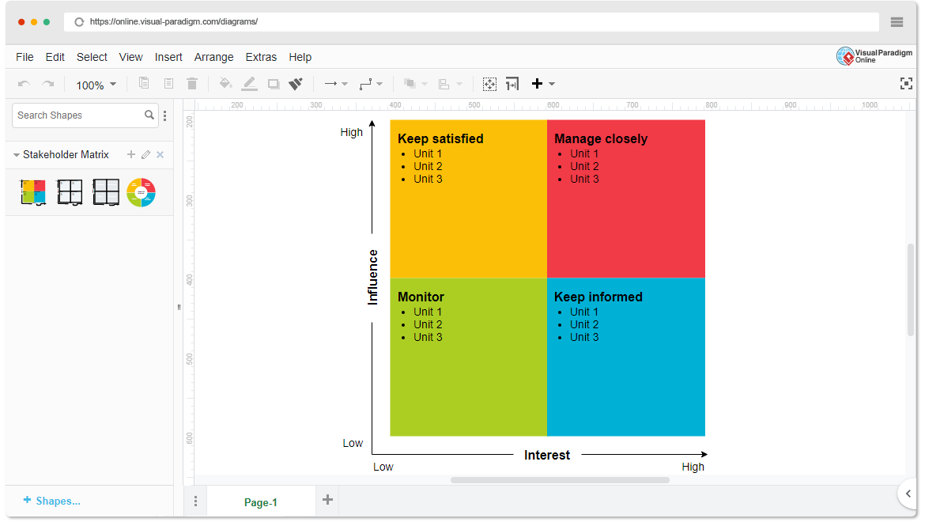

* High Power, High Interest: [Pharmaceutical Companies, Researchers/Scientists, Government Agencies (Funders)]
* High Power, Low Interest: [Healthcare Institutions, Tech Providers]
* Low Power, High Interest: [Patients, Patient Advocacy Groups]
* Low Power, Low Interest: [Public/General Community]